EXP 9: CREATE A VIRTUAL HARD DISK AND ALLOCATE THE STORAGE USING VM WARE WORKSTATION.
AIM:
To create a virtual hard disk and allocate the storage using vm ware workstation

PROCEDURE:
STEP 1:GOTO VM WARE WORKSTATION.
STEP2: RIGHT CLICK THE VM AND GOTO THE SETTINGS.
STEP 3: ADD HARDWARE WIZARD AND SELECT SCSI AND CLICK NEXT.
STEP 4: CREATE NEW VIRTUAL DISK.
STEP 5: SELCT THE DISK SIZE AS 2.0. AND SELCT SPLIT VIRTUAL DISK INTO MULTIFILES.
STEP 6: GIVE NAME AND CLICK THE FINISH.

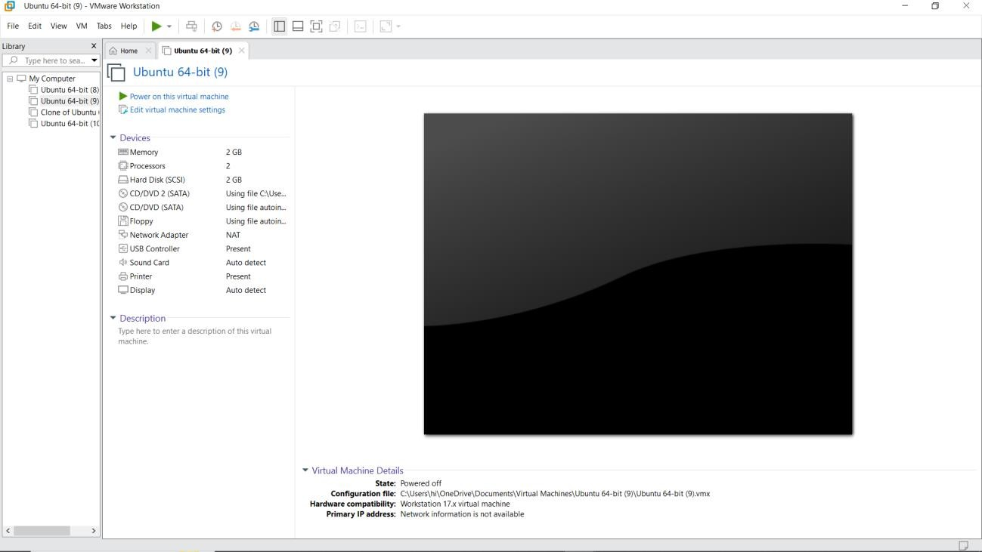
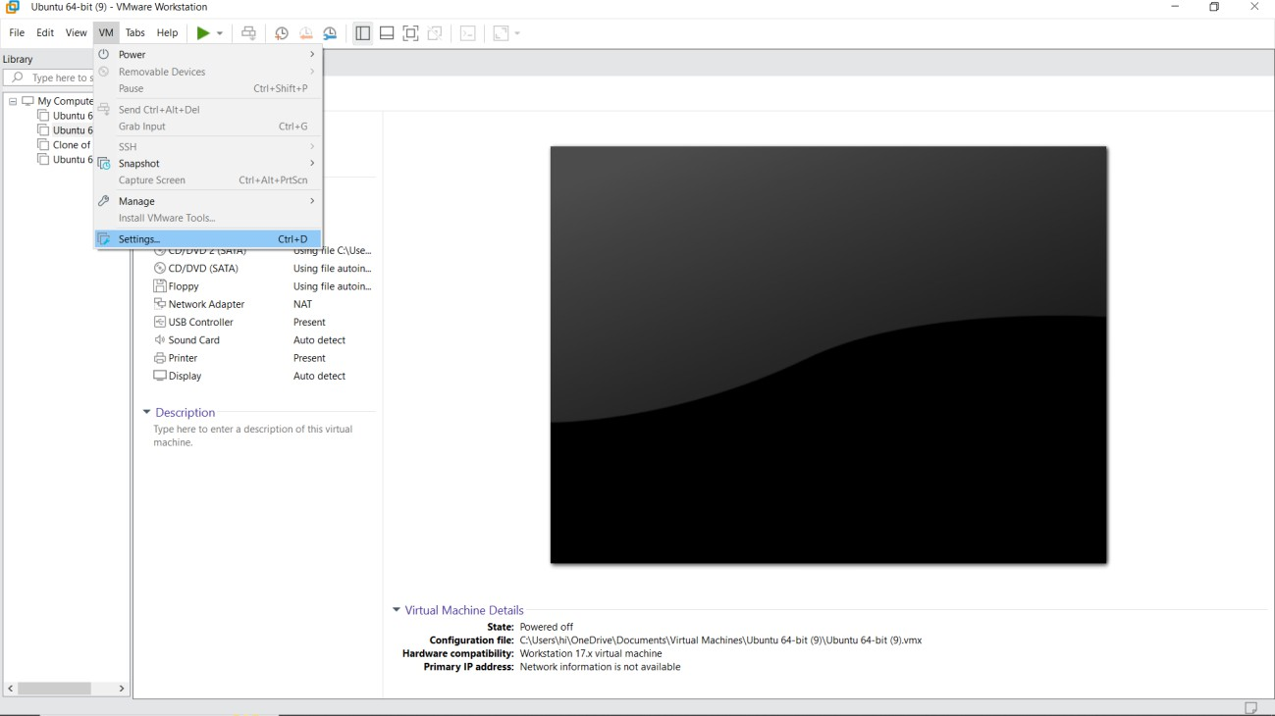
IMPLEMENTATION

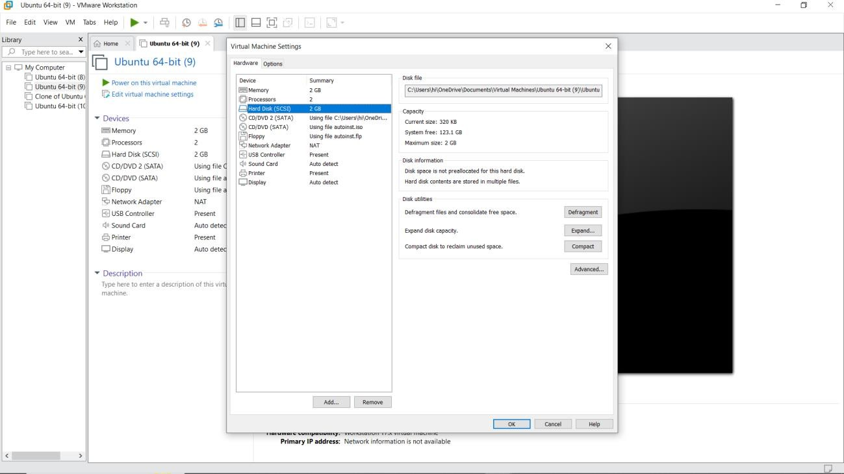
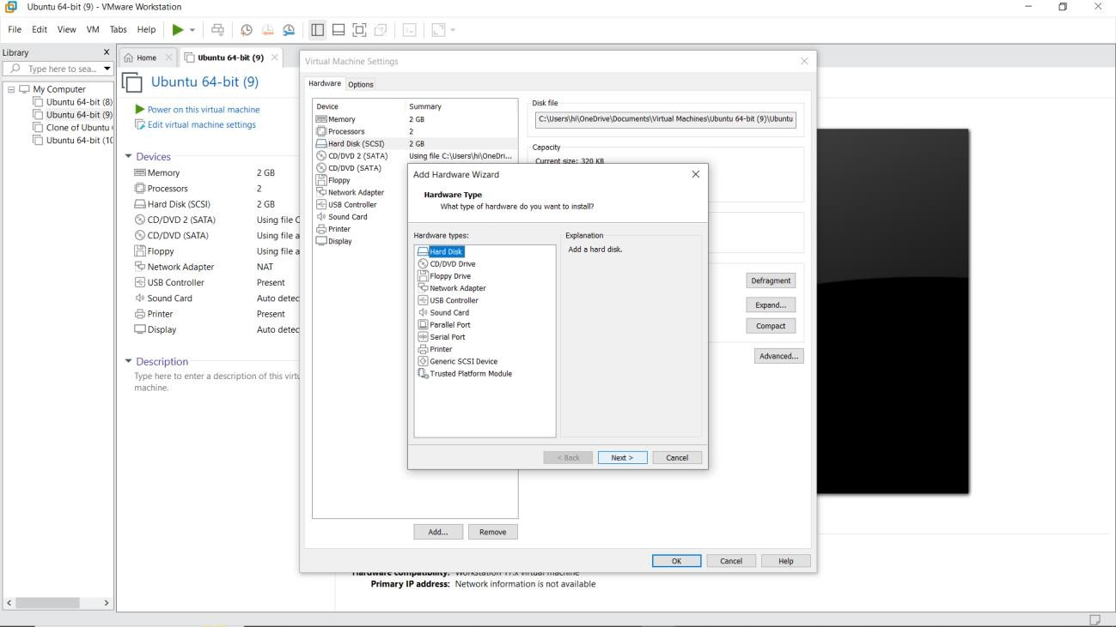

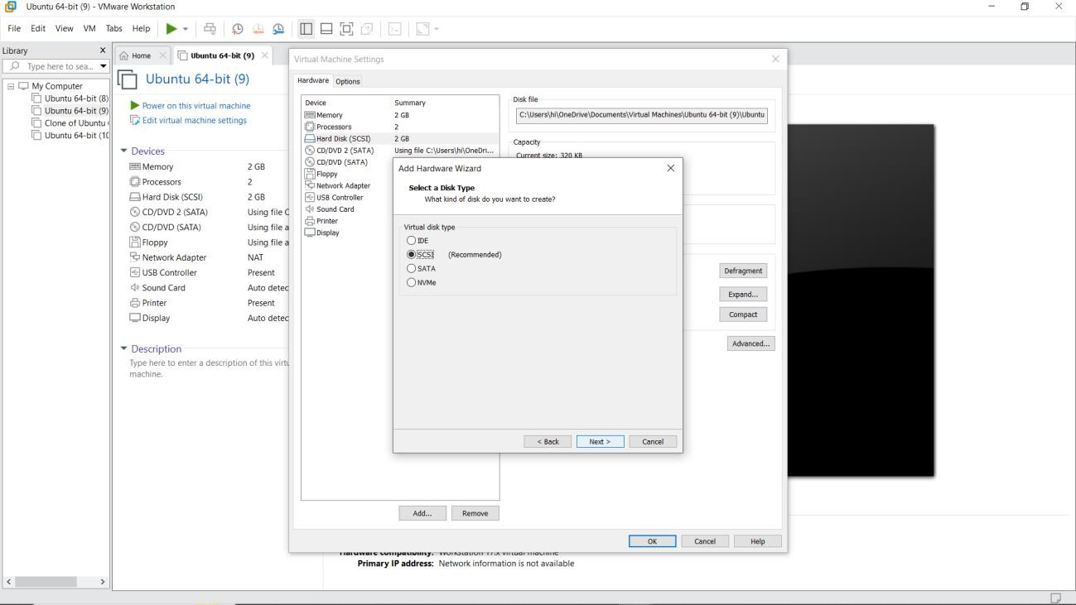
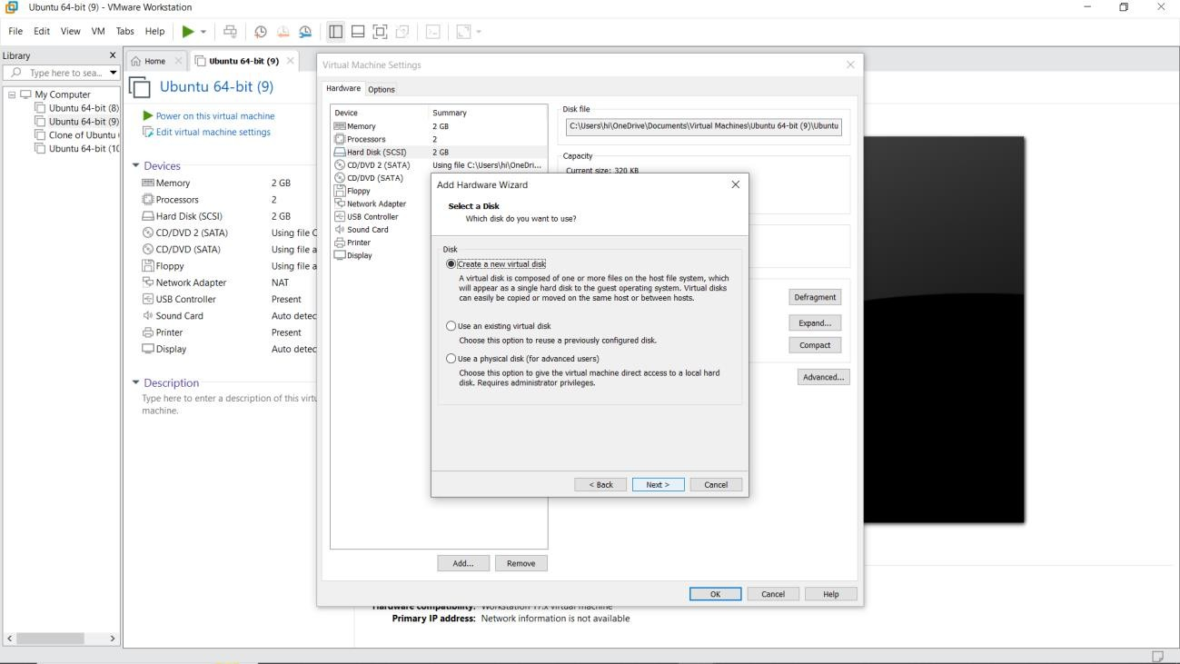

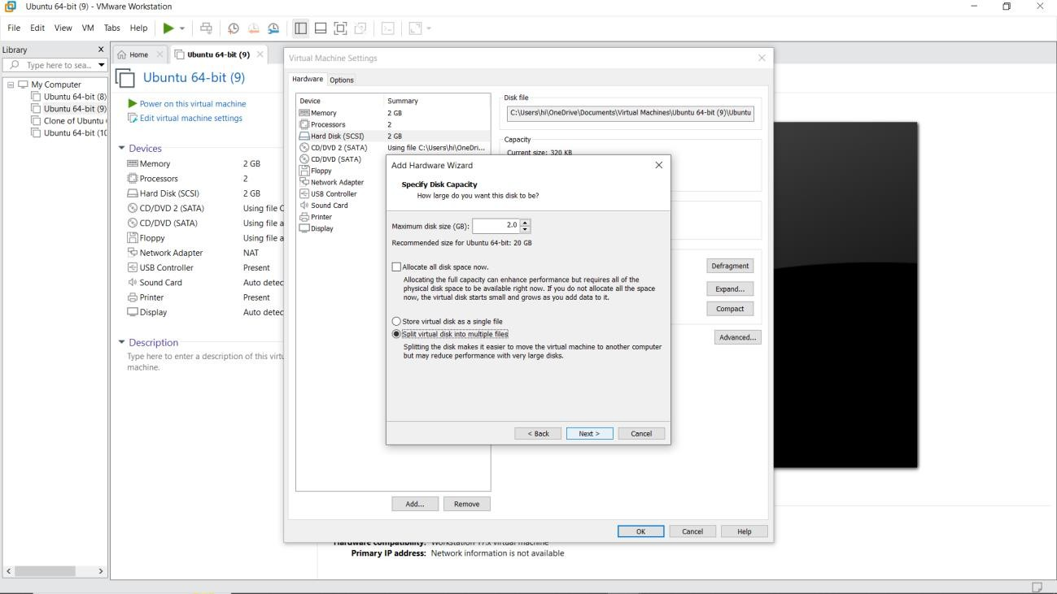
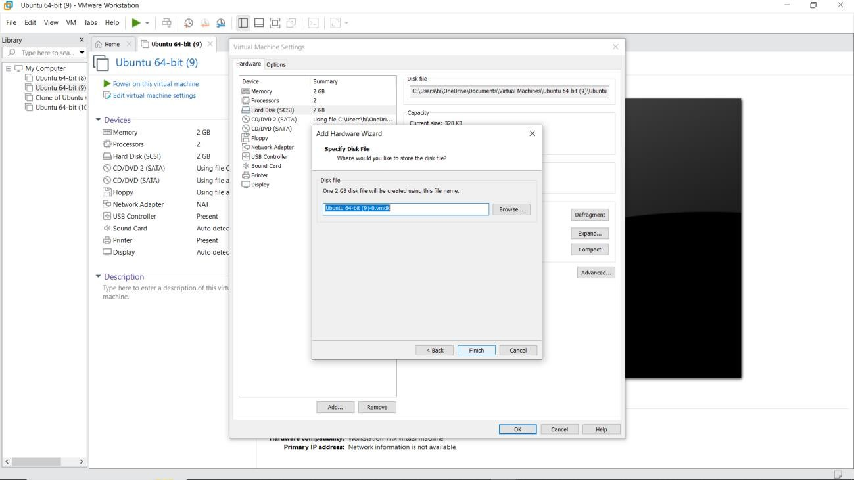

RESULT:
A virtual hard disk and allocate the storage using vm ware workstation has been created.

